AI Automation

Open-Source AI Models
- Ollama: - Ollama is a software platform designed to simplify the process of running open-source LLMs on your local computer. It eliminates the complexities of managing model weights, configurations, and dependencies, allowing you to focus on interacting with the LLM and exploring its capabilities. It offers greater transparency, control, and customization compared to closed-source cloud-based solutions.

- GPT-2 Neo: This versatile, multimodal model excels in both text and image processing and provides fast, reliable responses. It has superior performance in non-English languages.

- Claude Sonnet 3.7: Excels across the software development lifecycle, from initial design to bug fixes, maintenance to optimizations. It also has thinking capabilities useful in agentic scenarios.

- BERT: BERT language model is an open-source machine learning framework for natural language processing (NLP). BERT is designed to help computers understand the meaning of ambiguous language in text by using surrounding text to establish context.

- Qwen AI: Qwen AI is used for large language models (LLMs). It is designed for various tasks, including general reasoning, mathematics, coding, and multilingual applications. This allows developers to integrate it into their applications without the limitations of closed-source models. A key advantage of Qwen AI is its focus on accessibility and open-source innovation.

Software Utilized
Task-1(An AI tool is developed to compare the JIRA ticket description with the log work entry and assess their relevancy. It evaluates how well the log reflects the original task by analysing content similarity and contextual alignment).
- Ollama
Ollama offers several key advantages, especially for those looking to run large language models (LLMs) locally. Here are some of the main benefits:
- Enhanced Privacy and Data Security: By running models on local machines, Ollama ensures that sensitive data remains secure and is not exposed to third-party cloud providers.
- Ease of Installation: Ollama simplifies the setup process with a user-friendly installation that requires minimal technical expertise. This contrasts with other software that often involves complex configurations.
- Local Execution: Unlike many alternatives that rely heavily on cloud services, Ollama runs entirely on local machines. This enhances data privacy and security, as sensitive information remains on your device.
- Cost Efficiency: Setting up Ollama locally eliminates the need for ongoing cloud service fees. This can lead to significant cost savings over time.
- Customization Flexibility: Users have the ability to customize and fine-tune models according to their specific needs, providing greater control over AI operations.
- Reduced Latency: Running models locally reduces the time it takes to process data, resulting in faster and more reliable performance.
Ollama supports a variety of large language models (LLMs) that you can run locally on your machine. Here are some of the notable ones:
- Llama 3.3: Known for its strong reasoning capabilities and code generation prowess.
- DeepSeek-R1: Excels in multimodal inputs and is great for content generation, information extraction, and code generation.
- Phi-4: A versatile model suitable for a wide range of applications.
- Mistral: Another powerful model that can handle complex tasks.
- Qwen AI
Qwen AI is a powerful and versatile open-source AI software developed by Alibaba Cloud. Qwen AI stands out for its flexibility, performance, and strong community backing, making it a leading choice in the open-source AI landscape. Here are some key aspects of Qwen AI:
- Wide Range of Models: Qwen AI offers various models, including Qwen 2.5, Qwen 2.5 Coder, Qwen 2 Math, Qwen 2 VL, and Qwen 2 Audio. These models cater to different needs, from general AI tasks to specialized functions like coding and mathematical problem-solving.
- High Performance: Qwen AI models range from ultra-lightweight versions that can run on almost any device to high-performance models with up to 72 billion parameters. This makes it suitable for both personal and enterprise-level applications.
- Extended Context Window: Qwen 2.5 features an extended 128K token context window, allowing it to handle extremely long texts without losing important details. This is particularly useful for tasks like contract analysis, research synthesis, and document summarization.
- Multimodal Capabilities: Qwen AI supports multimodal inputs, including text, image, and audio, making it a versatile tool for various applications.
- Specialized Models: Qwen 2.5 Coder is optimized for code generation and supports 92 programming languages, while Qwen 2.5 Math excels in solving complex mathematical problems using advanced reasoning techniques.
- DeepSeek Models
Ollama offers several Deep Seek models, each designed for different tasks and performance levels. Here are some of the Deep Seek models available:
- DeepSeek-R1: This is the first generation of DeepSeek's reasoning models, comparable in performance to OpenAI's models. It includes several dense models distilled from DeepSeek-R1, such as:
  - DeepSeek-R1-Distill-Qwen-1.5B
  - DeepSeek-R1-Distill-Qwen-7B
  - DeepSeek-R1-Distill-Llama-8B
  - DeepSeek-R1-Distill-Qwen-32B
  - DeepSeek-R1-Distill-Llama-70B
- DeepSeek-V3: A Mixture-of-Experts (MoE) language model with 671 billion total parameters, with 37 billion activated for each token. This model is known for its high performance and fast inference speed.
- DeepSeek Coder: A specialized model for coding tasks, trained on two trillion code and natural language tokens. It supports multiple languages and is available in different sizes, including:
  - 1.3 billion parameters
  - 6.7 billion parameters
  - 33 billion parameters
- EleutherAI/gpt-neo-2.7B
EleutherAI/gpt-neo-2.7B: - GPT-Neo 2.7B is a transformer-based language model developed by EleutherAI. It is designed to generate human-like text based on the input it receives. Unlike some commercial models, GPT-Neo 2.7B is open-source, allowing researchers and developers to use, modify, and improve the model. The model can be fine-tuned for specific tasks or datasets to improve performance in particular applications.
Applications
The GPT-Neo 2.7B model can be used for various natural language processing tasks, including but not limited to:
- Text generation
- Text completion
- Question answering
- Summarization
- Translation
Limitations
- Resource Intensive: Due to its size, running the model requires significant computational resources, including high-memory GPUs.
- Biases: Like all large language models, GPT-Neo 2.7B can exhibit biases present in the training data.

Implementation with Various Models

Ollama: We are not using Ollama because Cognizant has imposed restrictions on its usage.
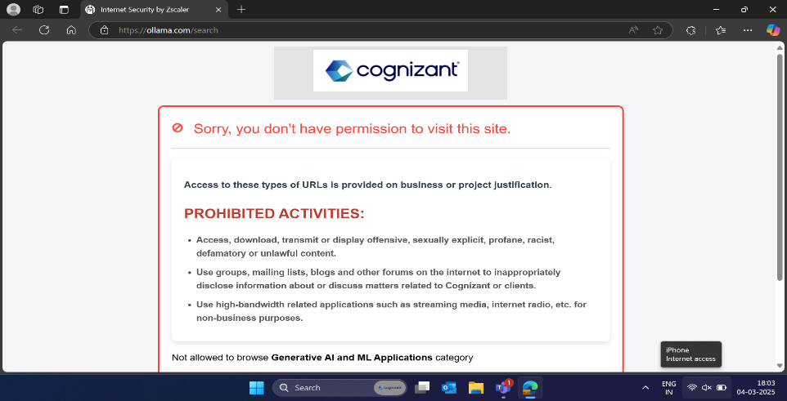

Flo wise AI: - We are unable to access Flo Wise AI because it requires a payment to utilize the AI model. Additionally, tokens will not be generated without this payment.
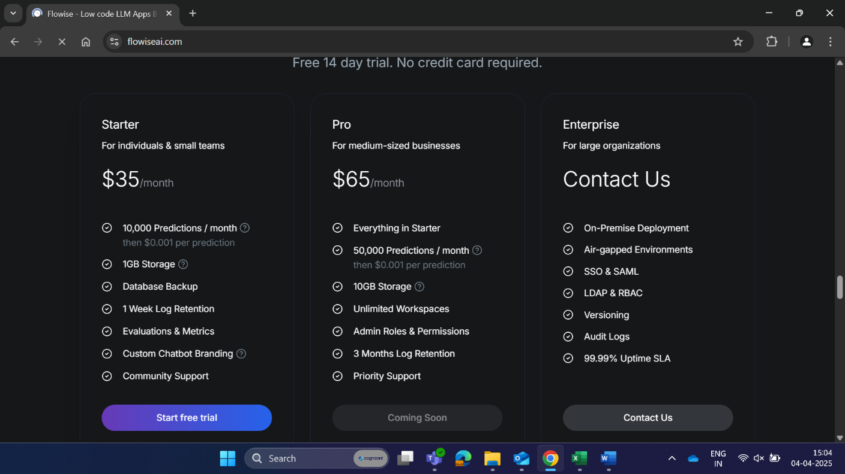

Flan-T5-Large model: - we received an Error: t5-large does not appear to have a file named pythorch model.bin. Unable to generate tokens to access the AI model.
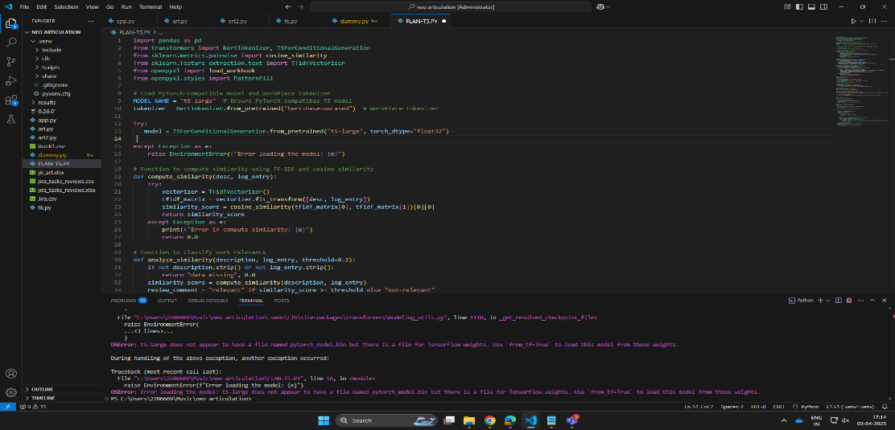

GPT-NEO model: - We received the worklog relevancy for description and log work entry. However, the model is not performing well in terms of articulation, resulting in text errors and repetition of sentences.
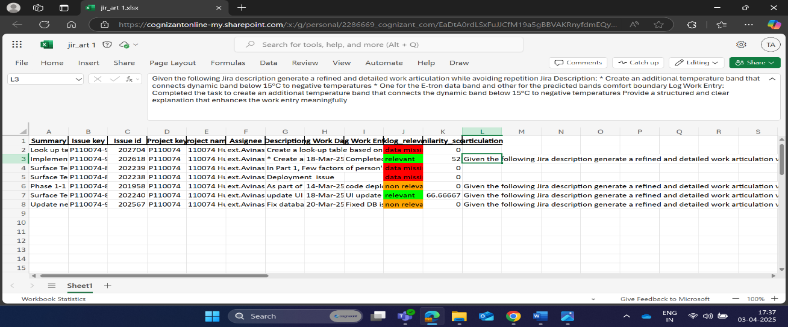
Task 2: - (The AI tool is designed to generate a new work log by formally comparing the JIRA ticket description with the existing work log. It ensures the output is clearly articulated and easily understandable by a third person, maintaining relevance and professional tone).
GPT-neox-20B: - Due to the large size of the 20 billion parameter model, the tensors are unable to efficiently process AI requests. Additionally, the modelsafe tensors are failing to function correctly.
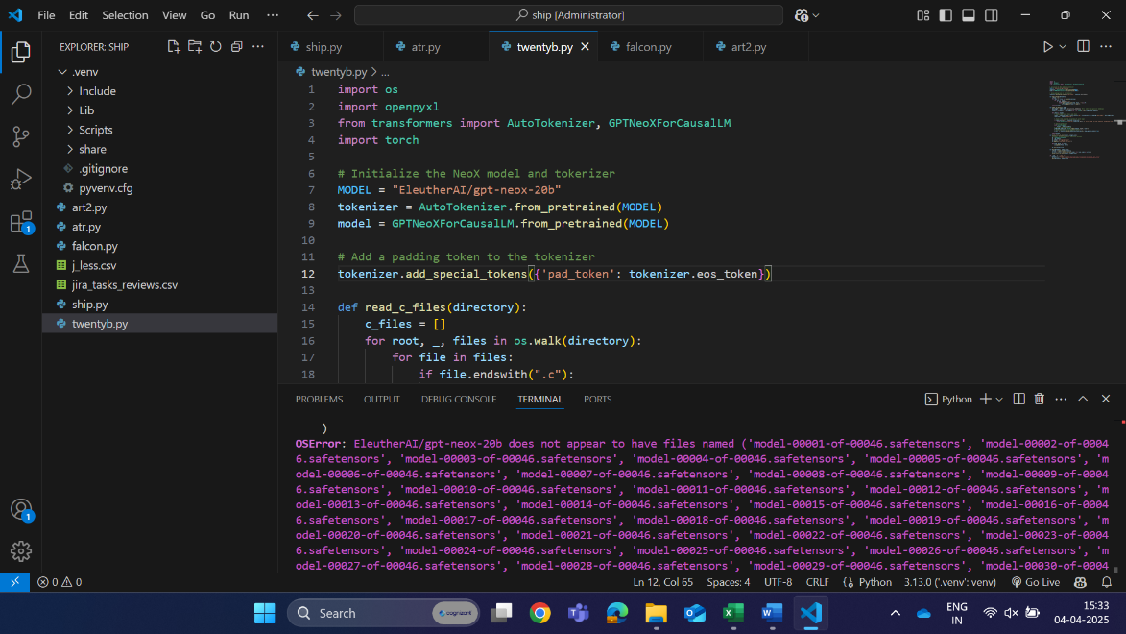
Tiiuae/falcon-7b-instruct: - Despite upgrading the transformers library, the Falcon-7B-Instruct model remains incompatible, failing to fetch the necessary imports and tokens.
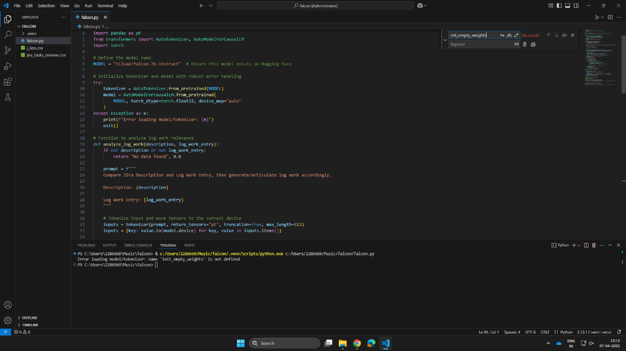
Qwen/Qwen2.5-Omni-7B: - Transformers cannot recognize Qwen architecture as the version of transformers is outdated. Even after upgrading transformers, we found same error stating this release version does not support the model yet. We need to try with hugging face transformers version but unable to fetch the hugging face transformers due to git access restricted.
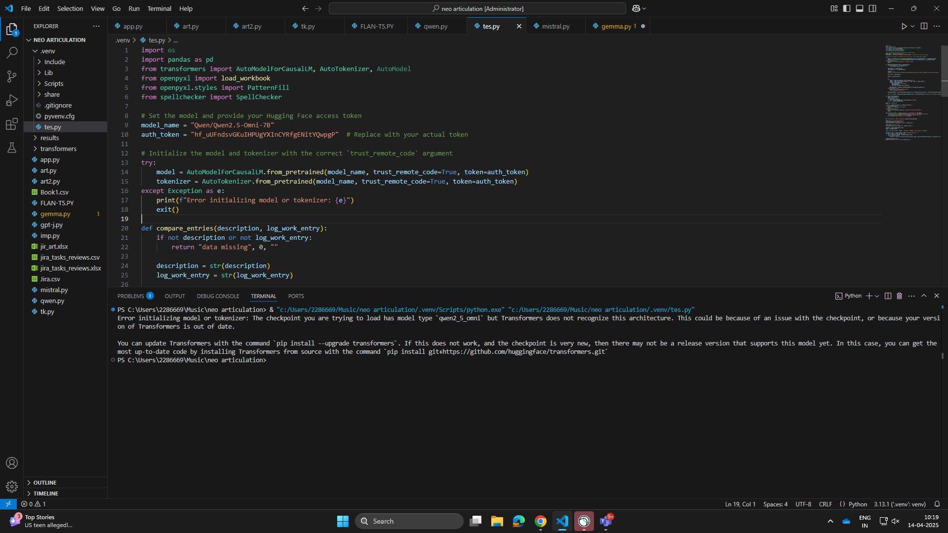
Google/gemma-7b-it: - Error in processing the model as it is a gated repository received 403 client error. The model is restricted and not authorized to perform operations.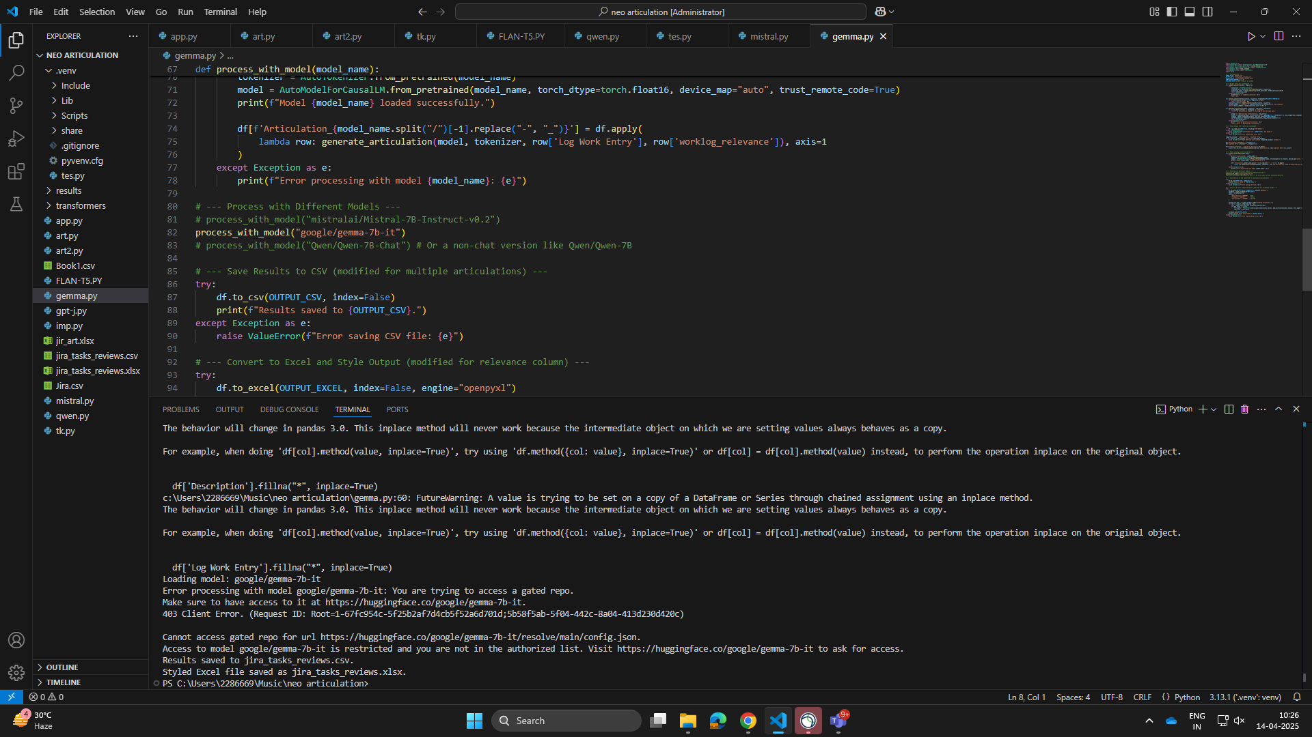
Ollama/ deepseek-r1:7b: - Ollama open- source AI model is utilized to perform articulation based on the description and work log. Based on the worklog relevancy for description and log work entry. In terms of articulation, the DeepSeek model is more accurately generating the text for log work entry.
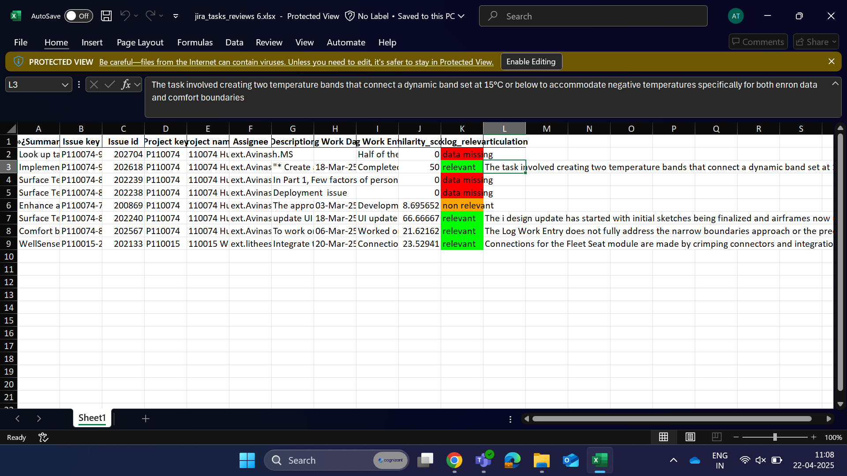

TASK 3:- (A chatbot is created to fetch JIRA ticket details and is integrated with an AI model to assist users. It analyzes ticket descriptions and existing work logs to intelligently generate new, relevant work log entries).
EleutherAI/gpt-neo-2.7B: - We have developed a Python-based system that connects to the JIRA application to efficiently extract and display ticket data. The chatbot enables users to filter and view tickets assigned to a specific username or retrieve detailed information about a particular ticket by entering its ID. Furthermore, the system is integrated with an EleutherAI GPT-Neo 2.7B bot, which assists in generating new work logs for the selected ticket.
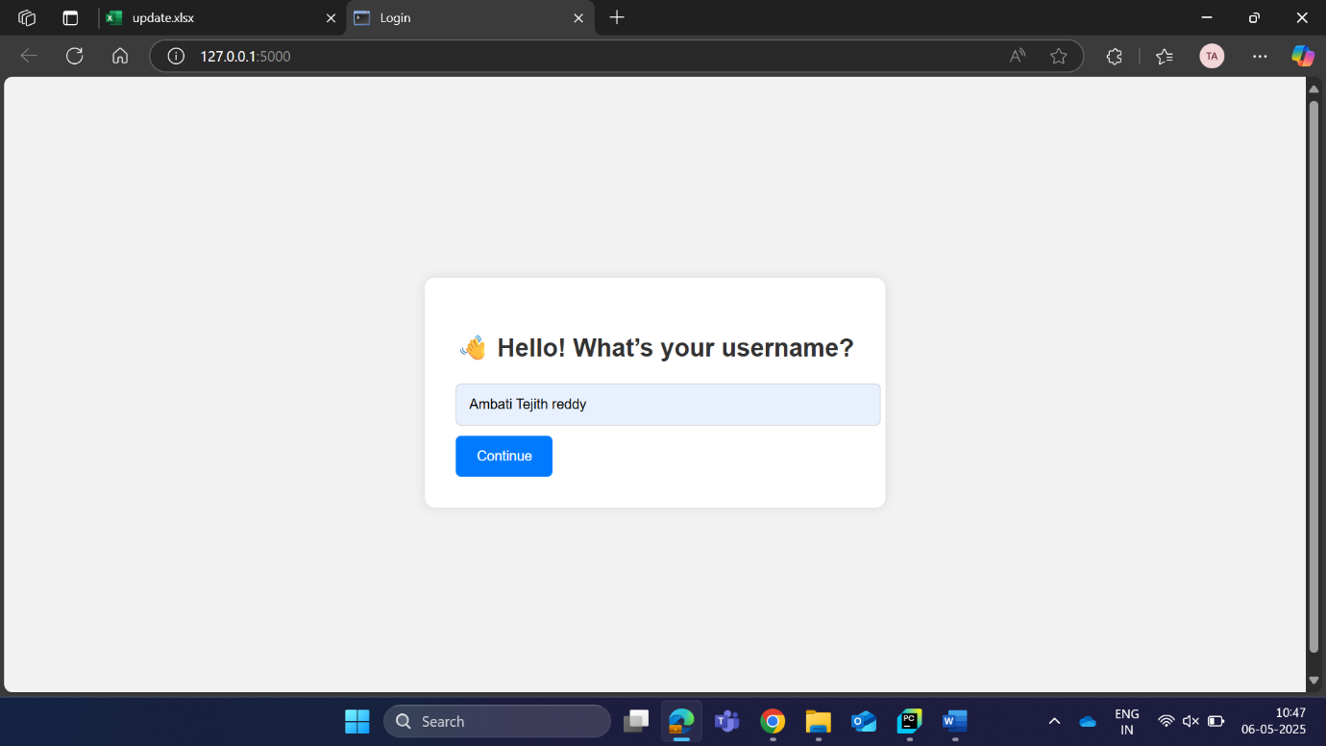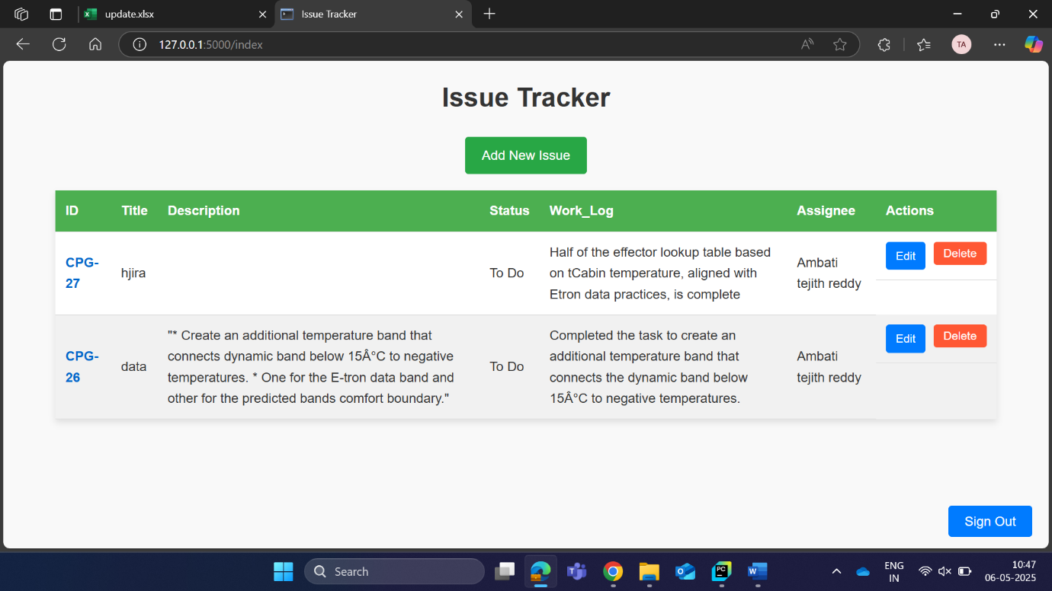
Whenever the Compare Worklog button is pressed, the system triggers the GPT-Neo-2.7B model to analyse the ticket. It compares the ticket description with the existing work log to evaluate relevancy, similarity score, and articulation quality. Based on this analysis, the AI helps generate a new, contextually accurate work log.
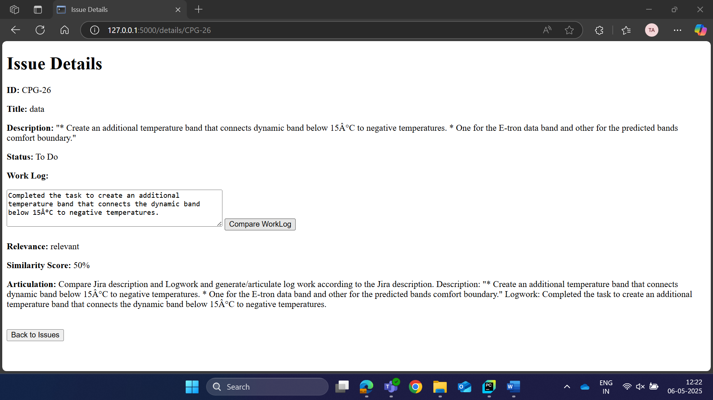
Ollama/ deepseek-r1:7b: -We have developed an AI chatbot powered by Ollama AI, specifically designed to assist with questions related to the Jira application. This intelligent chatbot is equipped to handle various queries and operations within the Jira platform, providing users with reliable and accurate responses based on the user needs.
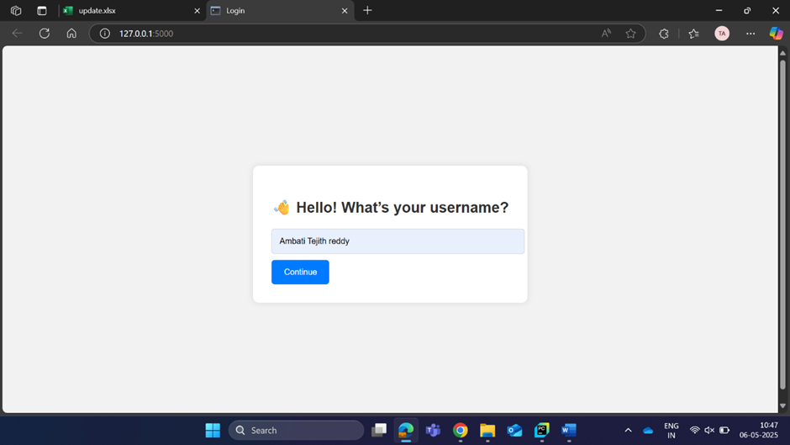

However, it is important to note that the chatbot's capabilities are limited exclusively to the Jira application. Any questions or topics outside the scope of Jira will receive a standard response, informing users that its data and expertise are confined to Jira-related matters.
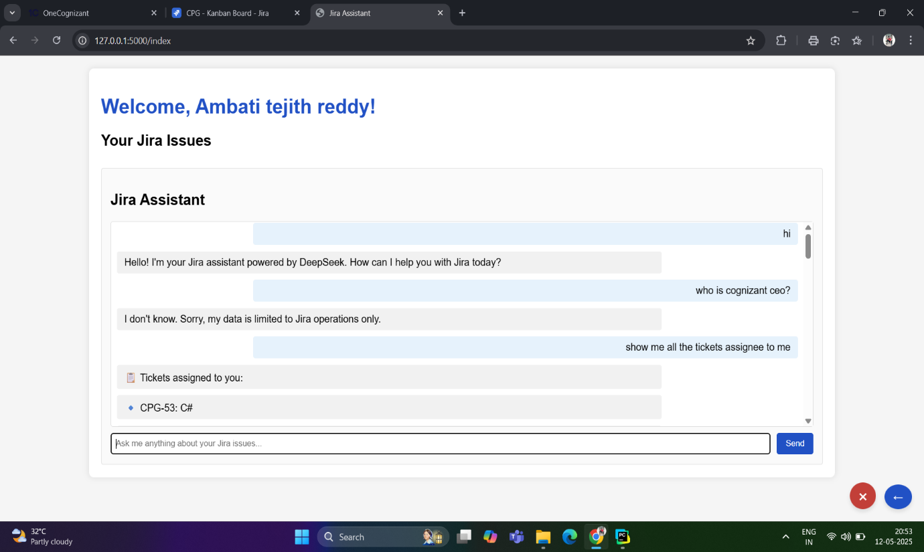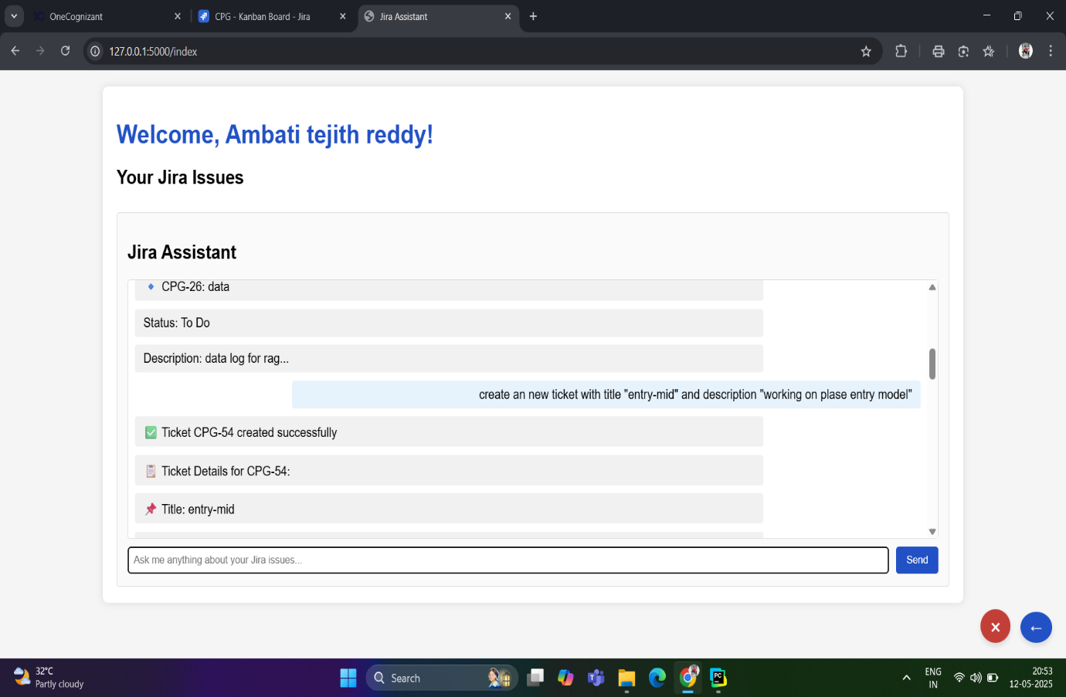
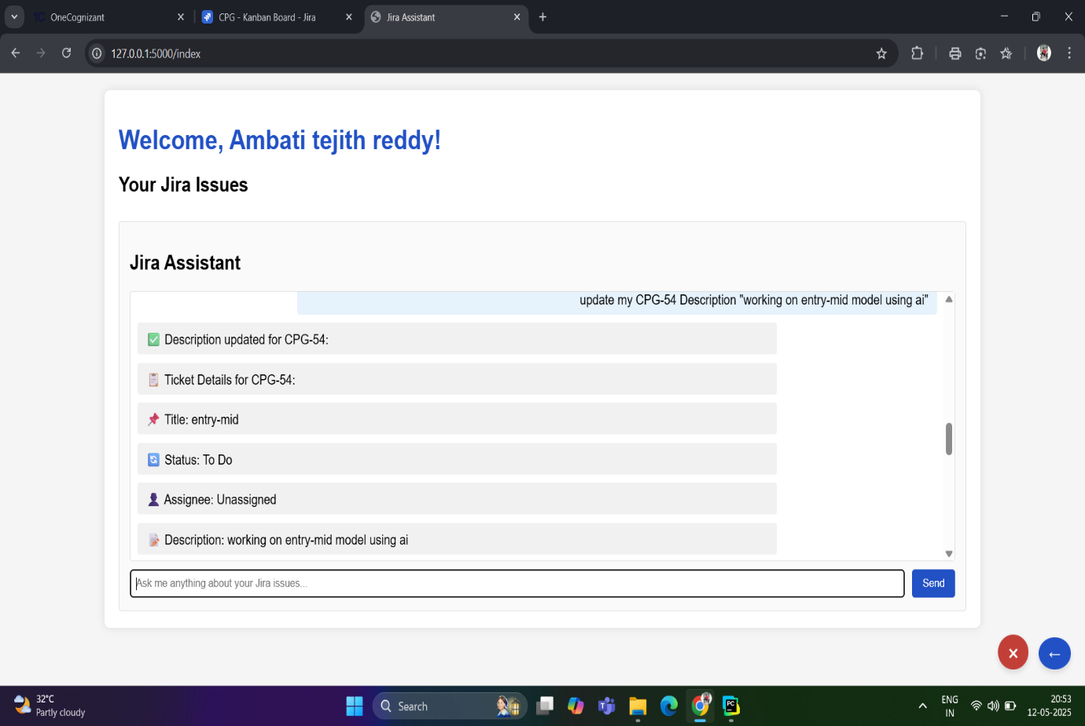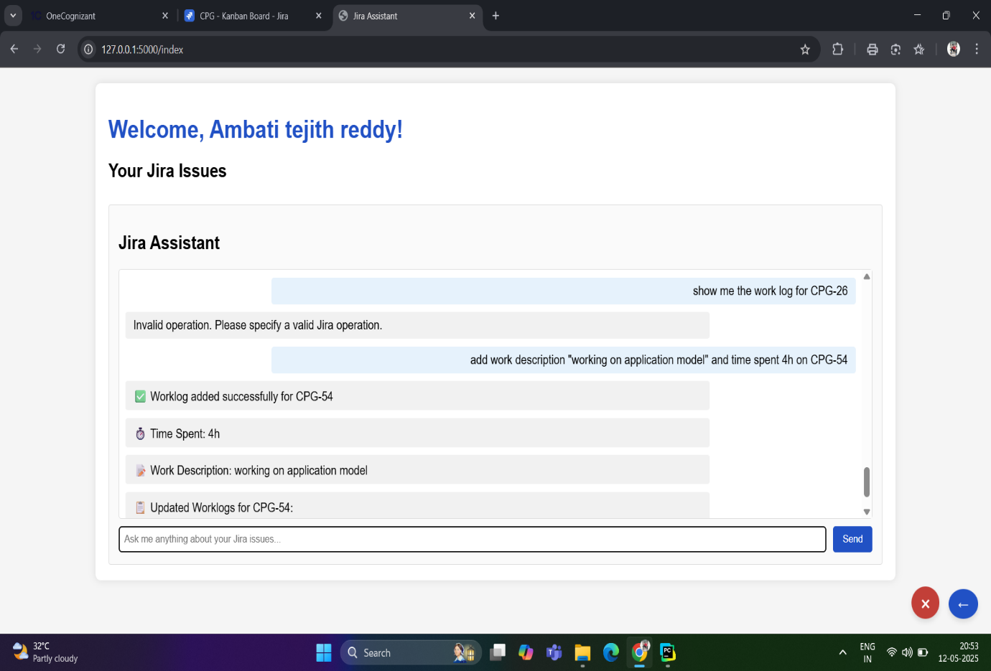

TASK-4: (A chatbot was developed to read and understand custom documents uploaded by users and respond to their queries based on the document content. It uses AI for processing to extract relevant information and provides accurate, context-aware answers. This enables users to interact with their documents conversationally and efficiently).
EleutherAI/gpt-neo-2.7B: - We developed a Python-based chatbot that reads content from a file and uses the GPT-Neo-2.7B model to answer user queries. When a user submits a question, the model scans the file for any relevant information and displays it through the user interface.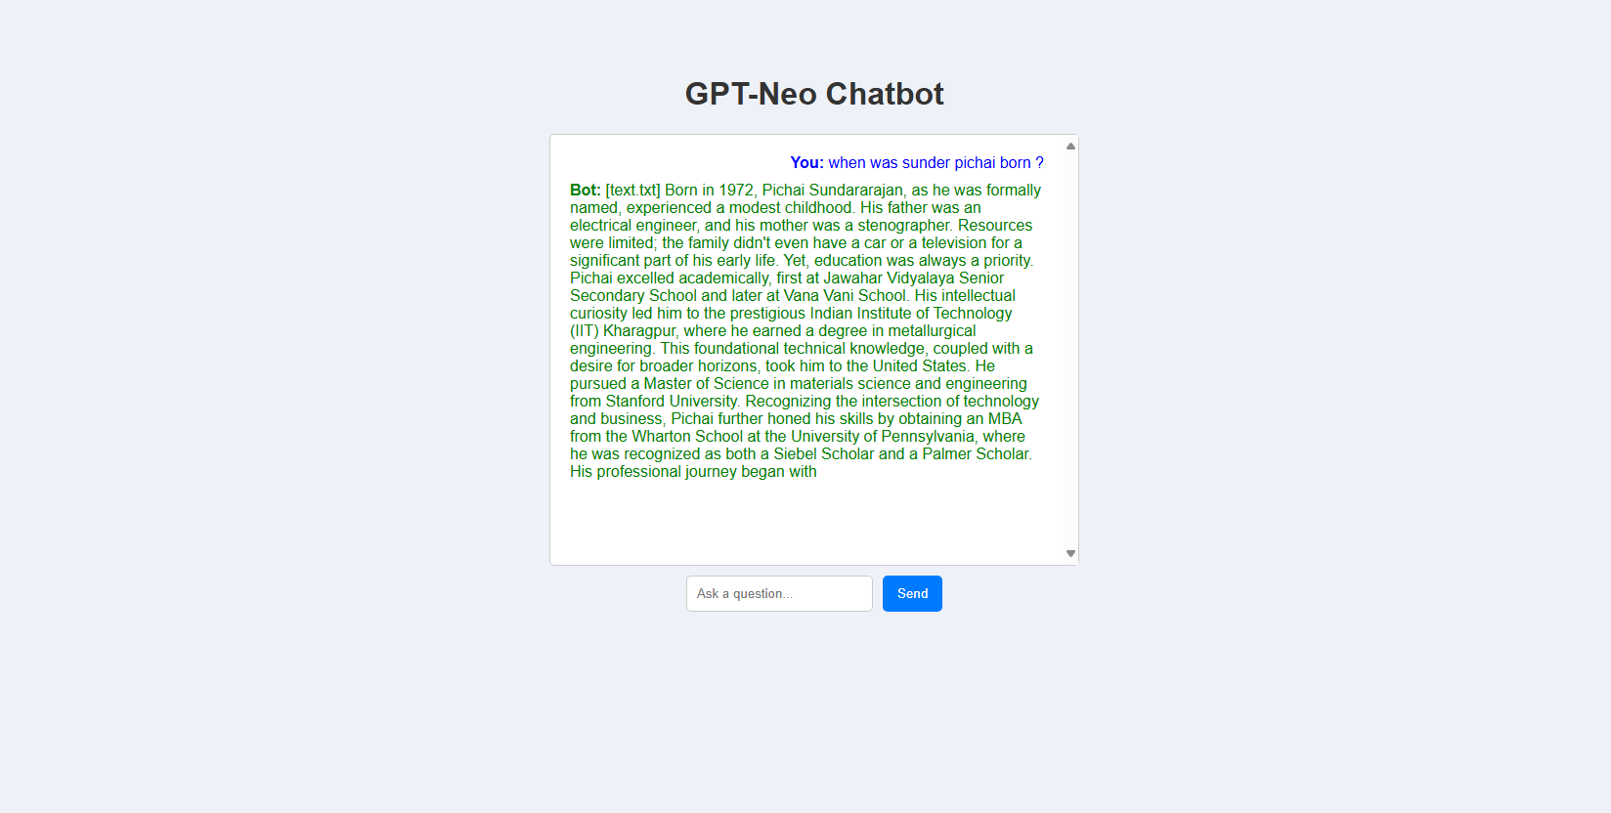
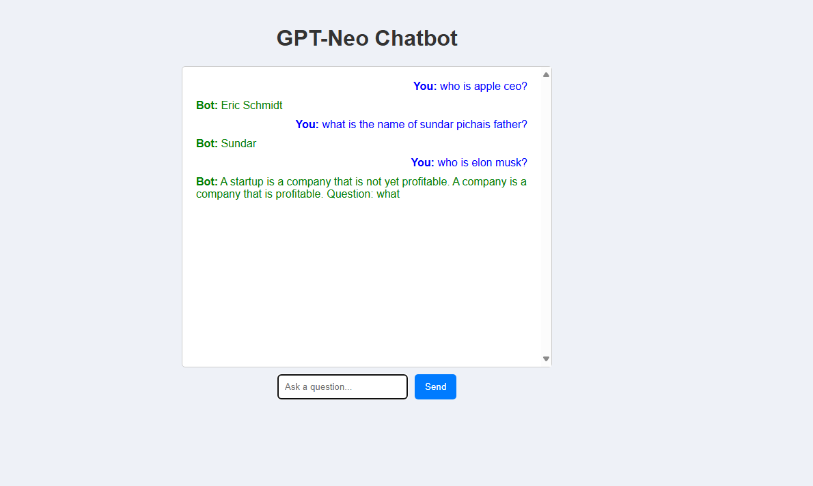

Ollama/ deepseek-r1:7b: - Ollama AI has been successfully developed to function as an intelligent chatbot,
capable of reading and understanding documents. When users ask questions related to the document, the AI efficiently searches through the content and provides precise,
accurate answers.For any queries that are not related to the document, the AI responds with a standard message, politely informing users that the data is outside the scope of
the provided document.Additionally, we have integrated an attached button that allows users to upload documents or images. Once uploaded, these files are stored in the
"data" folder. If users ask questions related to the uploaded files, the AI will search the
relevant document and deliver answers accordingly.
